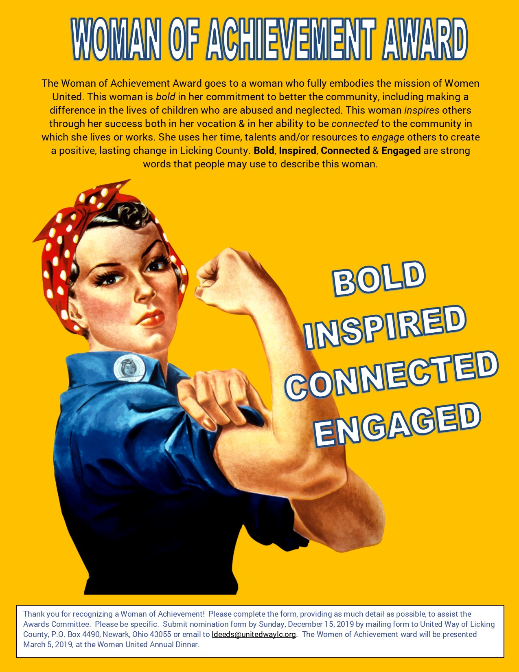

Woman of Achievement Nomination Form
Deadline for Submission: Sunday, December 15, 2019

Selection Criteria:
-Supportive of the United Way and supports the Women United mission (through time, talents or
resources)
-Is recognized by community as a leader
-Inspires others to volunteer or make a difference in their community
-Lives or works in Licking County

Please complete the following questions for the nominee:

Name:

Employer:

Phone:

Email:

-List career and/or life accomplishments:

-What impact does this person make on the community?

-How does this person support the mission of United Way & Women United?

-How does this person inspire other women?

-Describe why this person should receive this award:

Please list your information below:

Name:

Employer:

Phone:

Email

